### Overview

This program will be a **RPG-style game**. It will be, for now, a **singleplayer** game, focused on **ages 13 and above**. It will be a **high-quality low-poly/origami-style** game. The player can choose to create up to **20 different save files**, which each represents a single character, that can be, as of right now, **customised but with limits**. They always start off **with 100 for the 3 base stats** and at each level up they can choose to improve one of them **by 10**, **gaining** a **skill point** and **at some levels a path point**. The current **level cap is level 40**. The **difficulty increases as the player levels up**, to make the game **increasingly more difficult as the player gets better equipment**, making the combat A.I. more **efficient/more of a challenge** - towards the level cap, the A.I. will try to read the players moves and try - most of the time - to block the attacks, so the player should try to find **weak spots** or **be more defensive**, each enemy with **different attack styles**. **No login** is required. The game will, of course, be in **3D**. I wish to make it open-world, but due to limited resources it will have to be a **semi-open-world**, where I section the **maps into different districts**, all containing **different enemies and NPCs** of different levels - the next level loads upon travelling through a **boundary** that leads to the next map.

### Controls

#### Camera

In this program, the user will have the ability to rotate the camera around their character by **holding the right mouse button**, causing the camera to rotate with the mouse on a 2D plane, where up and down, make the camera look up and down, and left and right, make the camera look left and right, this is similar to the output of keys **Q** and **E** as it moves the character on a fixed position; however if they so choose, they can hold down the **left mouse button**, and instead of it moving them to a position, it will allow them to freely move the camera around the character, without disturbing the orientation of said character.  
Furthermore, the player will have the viewpoint **3rd person**, allowing them to control their characters from an external POV, and allow them to be more aware of their surroundings (in case of i.e. random encounters). Lastly, the player should be able to use the **middle mouse button** in order to change how zoomed in they are, centering in on the centre of the character, i.e. their back.

Optional - Hold MMB and move up or down to move the camera up or down the character on the y-plane.

#### Movement

In this program, the user will have the ability to either, use **click left mouse button**, to move to a spot specified by the player via quickest route, or use **click and hold left mouse button**, to move to the spot the cursor is pointing to, which includes if the cursor moves, until the hotkey is deactivated. Lastly they can use the **WASD keys** to maneuver themselves around this “open-world” environment, where the character will move at a set speed in a direction that is based on which way the character is facing, the player can also use two directional keys at once like **W** and **D** to move diagonally forward and right, however, a combination of **W** and **S** will result in no movement at all; this will do so until the keys are no longer pressed. Alternatively, the player may also use the **arrow keys** to move in a similar fashion, however, this will only take effect if the setting for its use in cameras is disabled. When using the movement keys the camera will not follow the orientation of the character, so it’s best to use it in combination with holding the **right mouse button**.

#### Accessibility

In this program, there will be many different hotkeys that the player can use to traverse the game’s many different features. The different keys are described as follows:

**Esc** Opens a menu that allows the player to select between different options,  
 pressing this button again or pressing “**Return to Game**” will close this menu.

Options:

**Return to Game**

**Save Game**

**Load Game**

**Settings**

**Exit to Main Menu**

*If you are in any other menu aside from this one, like your inventory, you may press this button again to close this menu, or press the same button you used to open it again.*

**F1**  **No Output**

**F2** **No Output**

**F3** **No Output**

**F4** **No Output**

**F5** Displays FPS.

**F6** **No Output**

**F7** **No Output**

**F8** Opens Help Menu.

**F9** **No Output**

**F10** **No Output**

**F11** **No Output**

**F12** Full-screens the game.

**`** / **~** Opens Inventory

**1** Hotbar 1 (Skill? Hold for charged)

**2** Hotbar 2 (Skill? Hold for charged)

**3** Hotbar 3 (Skill? Hold for charged)

**4** Hotbar 4 (Skill? Hold for charged)

**5** Hotbar 5 (Skill? Hold for charged)

**6** Hotbar 6 (Skill? Hold for charged)

**7** Hotbar 7 (Skill? Hold for charged)

**8** Hotbar 8 (Skill? Hold for charged)

**9** Hotbar 9 (Skill? Hold for charged)

**0 No Output  
- No Output  
= No Output**

**Tab** Swap Targets

**Q** Turn Left **W** Move Forward **E** Turn Right **R** Cancel Spell/Action **T No Output  
Y No Output  
U No Output  
I** Access Inventory **O No Output  
P No Output  
[ No Output  
] No Output  
A** Move Left **S** Move Backwards **D** Move Right **F** Sprint (Toggle) **G** Open Reputation Menu **H** Open Help Menu **J** Open Character Statistics Menu **K** Open Skills Menu **L** Open Lore Menu **; No Output  
‘ No Output  
# No Output  
L-Shift**  Allows access to Hotbar S1-9 **\ No Output  
Z** Hide/Show Weapons **X** Sit **C** Character Info **V** Open Journal **B No Output  
N No Output  
M** Open Map **, No Output  
. No Output  
/ No Output  
R-Shift** Allows access to Hotbar S1-9 **L-Ctrl** Allows access to Hotbar C1-9 **L-Alt/R-Alt** Allows access to Hotbar A1-9 **Space** Jump **R-Ctrl** Allows access to Hotbar C1-9

**LMB** Move to / Select Target / Rotate Camera

**RMB** Interact with / Select Target / Rotate Camera + Character

**MMB** Camera Zoom

**ADD COLOURBLIND OPTIONS**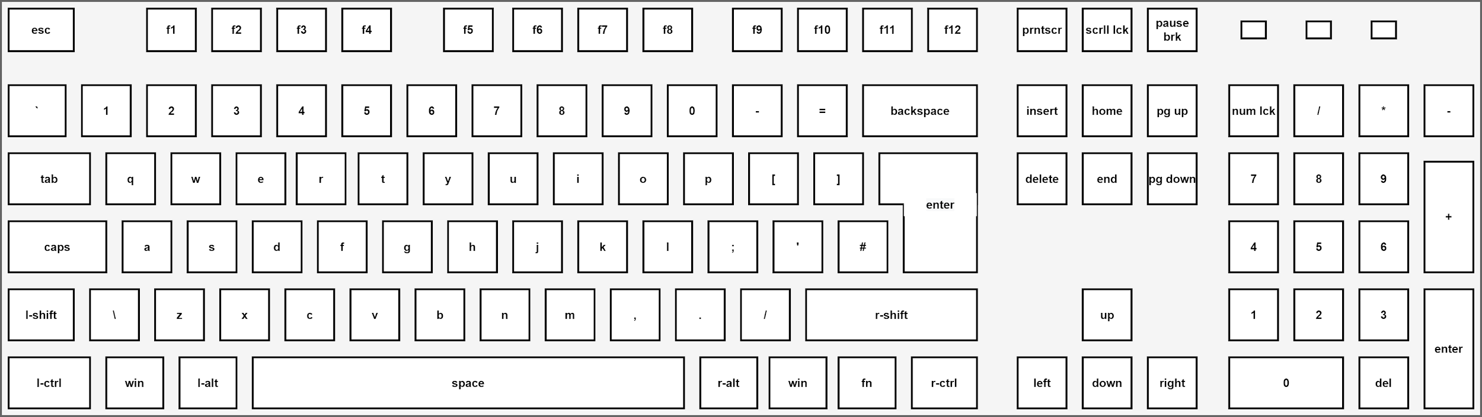

### Target Audience

The target audience for this program will mainly be for anyone **above the** **age of 12**, this is because, while it may not include swearing and the like, it will include **violence**, with bloody effects and the like. This program will only be available to **PC** users, due to the extent of my programming knowledge. This program will be aimed at those who love **platformers/puzzle** games, as well as **RPG** games.

### Thinking Abstractly

This program will be as **minimalistic** as possible, by reducing the amount of textures or amount of tris (**polys - shapes that are on the surface of an object in a scene**), making sure that the audience can read everything easily and absorb the surroundings well. Whilst doing so, I will make sure to include all the key features that an RPG needs, which I will do by performing abstraction on my program, narrowing down my program to sub-tasks that will make the foundations for the program.  
Key features of abstraction used in the program but not limited to would be:

* I will make sure I create an **easy to follow tutorial** that can be replayed at any time, this means that anyone new to the game or someone who hasn’t played in a long time, can **easily recall the controls** for the game.
* I will make sure I create an **easy to follow GUI** for the user, **displaying health**, and **armour points/defence** - perhaps even a **satiety** meter that measures a players **hunger** or **hydration** in game (increasing the complexity of this program).
* I will make sure I create **low poly to medium poly** assets that can be easily rendered by **low-end computers**, so most if not all audiences can play it on a **PC platform**. This may also include but isn’t limited to the possibility of me adding in additional options that affect the **rendering of object, models and the overall landscape**, i.e. within 200 units in a radius on a planar scale (**x and z**), only objects will load within that range, and everything else **will appear to be foggy**; this means that any objects that jut out at high y-level values will have their base **masked** by the fog - obviously if the player changes a setting, **they can increase this distance**, which **may or may not severely impact performance**. By introducing the fog, I can change the **poly render distance** in the game’s engine to just beyond the fog, and have it **individually load in each poly**,or in **segment**, that **phase in seamlessly with the environment**, giving a **nice aesthetic** to the game. Along with this, I’ll try my best to **implement some techniques** that enhance the **field of depth**, as well as textures, either **optimising them or making them detailed**. This will include but isn’t limited to: **Anti-aliasing (i.e. FXAA)**, **Shadows**, and **Anisotropic Filtering**; these 3 mainly cause the most performance issues for players, so these will become the **most scalable** in terms of how in-depth the player wants to view the graphics of the game.
* I will also make sure that the player has the ability to create random shapes of sizes based upon certain **formulas** that require materials one can gather from the current level or previous levels. These materials would like like any other material you’d find on your adventures, such as: stone, wood, dirt, flesh, absolutely anything; these materials will appear as a white material that has no texture, except for a **solid white atlas** that covers it, upon being placed, **it will copy the textures/atlases of anything below** it **by percentage** (i.e. 60% grass to 20% stone to 20% gravel would result in a dirt-like object). If a shape is placed on top of another, that doesn’t have a texture, it will not copy the texture below it, else if the shape is on top of another, that has a texture besides a blank atlas, it will copy the texture of the shape below; I plan to do this to help with creating a bond between the player and the landscape, allowing them to alter it as they see fit, without any blindingly bright white lights that glow at them from an untextured shape, which could ruin the immersion to some extent - the shapes will have a **luminosity of about 60%**, with a **soft glow/fuzz to the edges of the shape**. These shapes will come to be via the same method as the poly loading function previously mentioned; this will be where the shape will slowly fizzle into reality and become the desired shape - i.e. a cube or sphere or cuboid. In addition to this I will make sure to add a feature where they **can create their own custom shapes**, which when prompted will give them the option to **smooth out points** or **curve out edges to form nice, fluid shapes**, **which they can alter the shape of further**.

### Thinking Ahead

#### Controls

When I make the controls for the player, I’ll make sure they follow the general format of most games, such as **W A S** and **D** to move the character **away**, **parallel left**, **towards**, and **parallel right** to the camera respectively. Upon rotating the camera, that gives them a 3rd person view, their camera will become unfixed to the direction the character is facing, and this will allow for the player to look around, getting a full 360 view of their surroundings, if they use the mouse wheel they can zoom out or back in, however it will not zoom in further past a set amount. I shall also give the player the option to use a pathing system to find the quickest route to where they clicked with the **left mouse button**.

#### Heads-up Display | Graphical User Interface

When I make the HUD for the player, or rather how the GUI of the game will look, I will include a few icons in the lower right that have keys next to them, for things like the map, inventory, and other features. I will also include in this their health and perhaps, stamina points and mana in the lower left, or perhaps both depending on what I decide to implement. I shall also add a minimap in the top right, that has the option to zoom in and out by a fixed amount, this shall display things like portals to different places i.e. towns etc. It will also contain a fog of war feature, which requires the player to explore the entire map, and there will be a greyed out area beyond the player’s visible terrain, this will hide any enemies or like features but will still display the portals. Portals will not be displayed within the fog of war, prior to exploration and all areas explored will be permanent for that character. In the top left I will add timers for limited timed events, or buffs or debuffs which could prove useful when trying to farm a specific dungeon for a drop. Finally, I will have a hotbar that contains skills, that the player can use shift + scroll to switch between different weapon load-outs etc., not to mention I will have an exp bar at the top of the screen that displays the amount of exp to next level as well as progress; this would look something like a yellow bar along the top with the level specified in the middle, and below that would be the exp you have i.e. 576/1284 | 44.86% | Lvl: 24 . For in the very centre of the screen, I will add a crosshair that will help the players be more accurate with spells/skills and ranged attacks, as well as placement, however the crosshair will be dimmed significantly when the player is placing something as an outline will appear around the object you are placing.

As an option, I will additionally add a feature that automatically drinks health potions to help new people who may not be able to do this themselves, not to mention, I’ll add a quest tracker to their HUD to make it easier to reach quest markers etc. and the player will be able to move these two things around on their screen to however they desire, but will be limited to the size of their monitor and cannot drag things off their screen.

#### Terrain and Rendering

When I make the terrain, I will have to make sure that the terrain is how I said it would be, by doing this I create a large object, in this case a “map”, and I separate out each tri or face and arrange them in a 2-D array, as it cannot be made bigger or smaller, thus being perfect for such a task. When it comes to rendering such a large map, I will have the program introduce each tri or face procedurally, as the player goes in one direction, where each new tri or face, that happens to be inside the field of view, would be generated in all at once. One thing I could do to reduce the impact my rendering has on a player’s GPU is by using the camera in Unity to funnel only objects, or in this case tris and faces, within the field of vision, this means that the world is easier to load. When I make this feature I will make sure there is a decent amount of tris or faces either side of the camera’s FOV, so that the player can’t glitch out the system. One more thing is that the closer the tris or faces are to the player and their field of vision, the faster they load in, this will reduce the amount of white-space one may see if they jerk their camera around. Hopefully, this will be a great concept, or else I will have to stick to the original idea of loading everything within a radius that represents the FOV of the player.

If I am unable to create the loading in feature, I will resort to using particles to simulate the terrain loading and shaders that reveal the ground as the player walks. However, this will be resource intensive.

#### Skill Trees

Each time a player levels up, they will get a skill point, which they can choose to put into either their combat, social or workload trees. So far there will be no level cap for now, but the formula for experience required for each level up will be as follows , where the is 1000, the is the player’s level, and the is . Furthermore, there is an exclusive skill tree that is unlocked from level 4, within said tree will be abilities that the player can unlock for a certain amount of skill points, or as they level up, they can obtain an ability point, which can instantly unlock any ability of their choice that is available, setting its level to 1, and each additional level will give that ability either stronger affects or new ones. This ability point will appear every levels after level 4.

#### Quests

In terms of quest design, when it comes to dialogue, I’ll give players the option to skip the text based dialogue, or they can follow the storyline as they progress, as this opinion can differ from person to person, however, this is not recommended. I’ll try to make them as in depth as possible, hopefully not bland, but I’ll try to keep them short and sweet to make sure the user doesn’t get too bored easily. I might create some cutscenes, that take control of the camera, and have a fixed dialogue, and will be unskippable, aside from that though, the player can cancel most dialogue, however it may stop the story from progressing, requiring them to interact with them again. There will be sub-quests included as well, these could be things from hunting a select number of creatures, or defeating a boss and bringing back evidence of it’s defeat for a reward, such as exp and currency. Furthermore, I plan to add a quest tracker to one side of the screen. Another thing I will make sure is to add prerequisites to quests i.e. “You must complete Quest <blah blah blah> and be level <blah> to take this quest.”.

#### Towns

When I make the towns, I will make sure they are small, minimalistic but still contain a lot of culture and information; most houses will not be accessible, if not all, as most NPCs/Quest Givers will be outside of them - this saves the workload for both the developer and also saves time for the player, so they don’t have to constantly go in and out of a house, just because of a quest line. I’ll make sure that I place ideal NPCs near each other, such as a “Banker”/”Warehouse Manager” next to a “Grocer” or someone who sells and buys stuff from the player; depending on the quest line, the NPCs required for the quests may be scattered about town or within close proximity to one another. Finally there will be NPCs, that the player cannot interact with that have a set path they follow, to imitate a town.

These towns will be found within maps that contain a lot of wilderness and therefore a lot of enemies of that area's level.

### Thinking Procedurally and Decomposition (Top-Down Design)

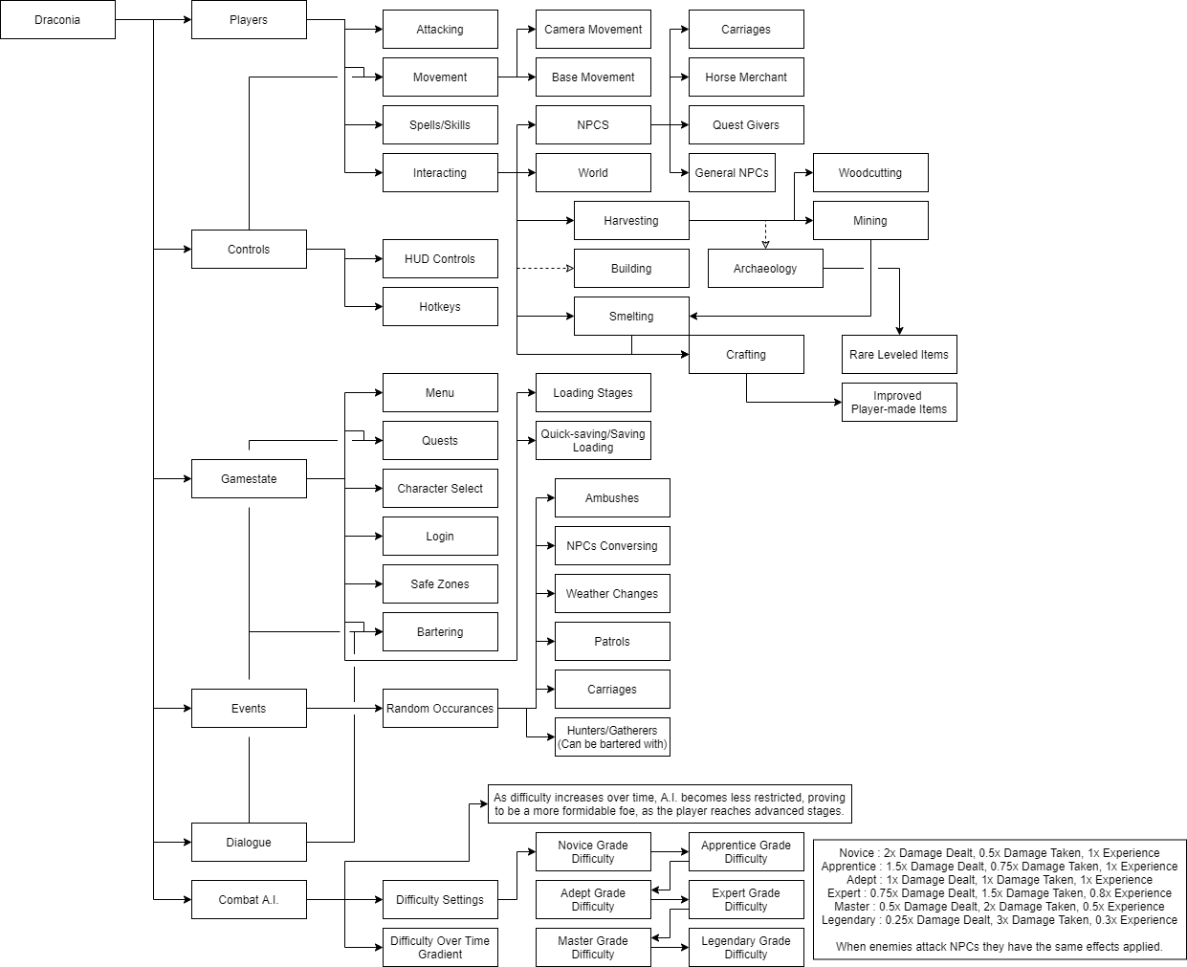

Above is my decomposition for my game, this will help me work on this project in steps.

* Players, broken up into multiple parts that focus on movement and actions in the game.
* Controls, broken up to focus on HUD controls and movement.
* Gamestate, broken up into multiple parts that focus on anywhere that may pause the game or provide an area to save your game.
* Events, broken up into a few parts to help develop the random encounters the player may be faced with when adventuring in the world or may overhear etc.
* Dialogue, broken up to focus on questing, general NPC chatter, NPC bartering.
* Combat A.I., broken up to focus on making the game more difficult as the play for longer.

### Thinking Logically

On the main menu, there will be a load game select (available if there are 1 or more save files available), if it isn’t available there is always a new game select (is still available after having 1 or more saves). There will also be an exit button, because they shouldn’t have to press alt+f4 or force close via task manager, as it could corrupt files. There will also be a settings area to adjust the volume and difficulty, and some HUD settings; in the settings you cannot change the graphics settings, only on the launcher or when prompted before start up.

I will make the weapons, spells/skills and player hitboxes apply their effects upon their hitboxes colliding with another, dealing damage if it’s a living thing. For the player it will be specifically the hitboxes of their fists, that becomes enabled when the player tries to deal unarmed attack damage. Weapon hitboxes will be specifically the blade only, and magic is well, magic, and deals damage so long as it hits a living thing.

Game should generate a new save file within the save game each time it loads, but not after loading a game save. In the settings the player can choose to enable a setting that saves every so often, i.e. 30 minutes, and when it saves, like when waiting, or when entering a new cell.

### Thinking Concurrently

Because this game is an RPG and all instructions should be processed in real-time and not like turn-based games, there should be processes being made by the A.I. of the NPCs (incl. Enemy A.I.) that occur at the same time as other processes in the world, such as world generation, generating events, or generating events (coding events) by the player interacting with the world around them. This increases the flow of the game and makes it more consistent instead of having short abrupt points in the game for combat or general movement around the world.

### Research - Game Comparisons

*While I cannot access these games from college, I can from home, and I somewhat actively play them.*

#### Genshin Impact (28 Sept. 2020):

**Genshin Impact is a semi-open world game and is constantly expanding in terms of regions you can visit.**   
*This is what I plan to do for my game, eventually making it into a large scale game where you can go for hundreds of kilometers in any direction, where the further you are from the main quest line you start to face tougher enemies. This means I have to increase limits for the player levels and enhancement/refining levels. I could also add a “****pure****” version of the different elemental powders, this means there won’t be any penalties and may provide a better bonus.* **In Genshin, they have a gacha system.**  
*This is not something I plan to add into my game, despite it being a good way to gather funds and draw people into buying stuff within the game to buy more stuff for their characters, I don’t want to create an unfair experience among the playerbase. I will, however, use a similar version to how they have implemented multiplayer into their almost completely single-player open-world, and has no aspect of PvP in the game, if players demand for it, I’ll make sure that if I do end up adding stuff that can help boost their characters, that it has no effect in the PvP Arenas and everyone has the same equipment, to make things fairer - this will take a lot of balancing but after a couple ten patches it’ll be ready for official release.*   
**Genshin Impact, is a game of exploration and telling a story of a fictional distant land where you play as any character which you gain via “**[**Wishes**](https://genshin-impact.fandom.com/wiki/Wishes)**” or via the main story line, you’ll first start of with either Aether or Lumine, brother and sister (respectively) depending on who you choose during the introduction to the game.**  
*I do not plan to do the same, I plan to have the player make their own character to their own desires, see* *Character Creation* *for more information, and then the game will appear to have the same features, like exploration and telling a story, but this story isn’t fixed like Genshin’s, it will be a game where the story’s path depends on decisions from the player, so they are more likely to pay attention to the story line, if they skip past it (which they are given the option to, they may lack critical information for later in the story, so I should only apply a skip function for them where appropriate, and add a slow mode to the “next dialogue” button, so they cannot spam it and they will have to read it, I will also add a visual prompt such as a golden border around the text box or wherever it is contained, this will help convey that it is imperative that the player learns this information.***Genshin Impact contains a way of improving equipment and refining their abilities, and these abilities that are only given to the equipment beyond a quality of [★★★☆☆], not to mention it doesn’t include anything along the terms of armour, but instead includes artifacts that give set bonuses and passive bonuses that can also be upgraded (but not refined), only artifacts with a quality rating of [★★★☆☆] or higher will have extra bonuses to their randomised statistics, such as Max HP +30.7%, where [★★★☆☆] or higher has Max HP +30.7% *Attack +3.1% Defence +6.9%*, for example. In addition to this, it includes ascension phases, that range from 1 to 8, where each stage requires a max level of 20, 40, 50, 60, 70, 80, 90, 100 respectively along with increasingly difficult materials to gather.**  
*I will implement a similar feature into my game, where the player can have artifacts (which will be replaced by jewelry, like rings, bracelets and necklaces) along with armour and weapons. These will include similar stat improvements but they will have completely different abilities for certain pieces of equipment; for example if you wear a certain ring, whenever the player gets hit, there is a chance for the enemy to be knocked prone as a result of their own attack, such an enhancement would be called something like “Fortitude”, and such enhancements will exist in large numbers. I could also add a feature where they can refine their equipment like the can in Genshin, causing any enhancements to have their effects increased, for example with “Fortitude”, the chance to knock prone increases with the refining level and a small chance to stun is added. However, such effects should only be applied to enemies of similar size and/or lower weight. Any large creature, like an Ogre, would be unaffected by the enhancement but would instead suffer something like a stagger for a small amount of time, or it will not be affected at all. I will not include the ascension phases as it will add a whole different level of complexity to my game that I do not particularly want to deal with.***Genshin Impact contains a method of climbing and flying, along with a stamina bar that can only be increased by offering the respective element oculus, for example anemoculus (air), to its respective statue.***I plan to use something similar, as I will contain similar things, except no stamina bar that is affected by either of these features, or statues that one can offer oculi to. See the* *Climbing* *section for more information on how I plan to apply climbing into the game. Flight, however, will be just gliding from one place to another using physics equations, along with drag coefficients etc. It will take no inputs besides directional movement to help steer oneself in a different direction. The player will have to try their best to maintain control of what method they are using to glide due to turbulence; this would involve holding in a direction to stabilise themselves or veer off to one side or straight down, but if a gust of wind lifts one up, you can go with it or you can minimise your size to make sure you can fall (similar to how birds of prey dive). View the Flying section for more information.*  
**Genshin Impact includes a World Level system where the world around you gets progressively harder as you reach different Adventure Ranks, which allows you to temporarily bypass a restriction which prevents you from refining, enhancing and ascending characters or items to a higher level.***This is something I like, and will almost definitely add to my game as it adds a level of complexity to my game and helps restrict players from boosting themselves to higher levels so they can blaze through the main quest line or sub-quests; when it comes to adding a multiplayer feature (if demanded) I’d have to find the average World Level between the players and then find the respective levels for each enemy. Whilst still using the equation in the* *Linear Progression* *section to help determine the level difference in said area.*  
**Genshin Impact contains levelled main quests and sub-quests to minimise fast progression throughout the game, that uses the Adventure Rank of the player. Sub-quests also have a chance of randomly occurring.***Such features I will also include within my game as Sub-quests give this feeling of immersion to the game and it also helps to limit the player on how quickly they can progress, if their level meets a set limit, they will no longer get exp, but instead will accumulate it, and when the limit is lifted the gain a portion of that exp based on how long ago they hit said limit, using the following equation:  
  
World Level; Limit Exceeded Time;  
Experience Gained Exceeding Limit;   
Player Level;  
For more info view:*[*https://www.desmos.com/calculator/cjofdtvd8s*](https://www.desmos.com/calculator/cjofdtvd8s)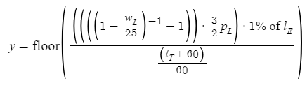

*This will only retain any experience gained after the limit to the next limit as to avoid insane amounts of farming of experience. I could also implement a feature where if they kill more than a certain amount, according to the world and player level, the experience they get will be substantially geometrically reduced. This equation will never affect the drop rates or how much are dropped, it only affects the experience gained for the player (if tried to circumvent via party experience share, then apply the same formula, reset the counter every 24 hours). The following equation will be used:  
  
Max Kills; Player Level; Monster Level;  
  
For more info view:*[*https://www.desmos.com/calculator/tf5k6djtpb*](https://www.desmos.com/calculator/tf5k6djtpb)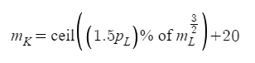

**Genshine Impact contains areas within certain regions that require certain characters to access, making people more inclined to use “**[**Wishes**](https://genshin-impact.fandom.com/wiki/Wishes)**” using Primogems, which can be obtained from discoveries, chests, achievements, quests or as bonuses to dungeons such as the “**[**Spiral Abyss**](https://genshin-impact.fandom.com/wiki/Spiral_Abyss)**”.**  
*I will avoid creating these areas that are specific to certain aspects of the game that require you to purchase things, but I will still create ones that are freely accessible to everyone, such as hitting something on the other side of a chasm using a bow and arrow or a spell. As for dungeons, I will also include similar ones, which can be repeated freely daily up to a few times, and any attempts to exit, will forfeit any items they may have picked up along with any gold and experience points and will kick them out of the dungeon. If the player has conquered more than a certain portion of the dungeon then their attempt will be voided and they will not be able to regain it until it resets the next day using global time, not the computer’s time. The player will also have access to multiple difficulties of the dungeon depending on their world level, any unconquered dungeons (where the player hasn’t beaten it at least once) then they will get a first time bonus for each difficulty, which will last until they clear the dungeon.***Genshin Impact contains an elemental reaction feature where different kinds of elements that mix cause different effects, such that pyro and cryo cause the melt debuff, or such that pyro and electro cause the overload debuff.**

*I will add a similar thing into my game however I do plan on trying to keep things like infernal (fire powder) armour from reacting with electrified (thunder powder) weapons or items. \*\**

#### Wynncraft (16 Apr. 2014):

**Contains a feature in which you can collect elemental powder from dropped enemies or loot chests; these powders can be used to upgrade your weapons or armour to give them certain properties, causing them to benefit from things like for weapons, n% of neutral damage is converted into the elemental powder type of damage, and an extra flat range is added to it, and for armour it adds a flat integer of resistance to the elemental powder type and a weakness to the opposing element, so if Fire Powder was applied then you would gain a resistance to fire damage, but would have a slight weakness to water damage.**

*I plan to add a similar thing to what they have included in their game, where they have a range of powders (from strength 1 to 6, that change their benefits and detriments accordingly to strength), however I do not plan to have a feature where they are added in a similar way to how they have done it. I will have it combine with the secret stones feature I plan to use from Aura Kingdom, just seems to be a better way of doing it; I will also add a feature where if the player is making armour or weapons and burns the powder (of whatever strength) it will apply it to the forge and they can create items with the same thing as if they just put powder on the item (which they can’t do). That will be the only non-secret stone way of adding it to items.*

**Wynncraft’s map is stunning as it contains so much detail in such a small space; it contains two provinces and has levelled areas, each area having their own quests and side quests that fit the storyline of your character you play. The layout of the map works well with having to progress through the story and unlock new quests, and it also prevents the player from entering areas that are quest or level locked (most areas aren’t locked at all, allowing for players to progress and level off high level enemies).**

*I want to include the same kind of map layout that they have gone for, but I’ll try and keep it as simple as possible and I’ll make it so the player can view a 3D map and they can view the world from any angle, limiting how far they can zoom in and move around the map. Not to mention I should use the quest and level locking they have used at certain areas, this will help keep players where they need to be in order to progress, if they do try to leave these areas, then they will be prompted with a warning each time that can be turned off in the settings about it being an unsafe area, still allowing them to explore and find things; I should also add a feature where if the player is in combat with enemies their level they get the normal amount of exp, but for every level above their character level up to a max of 10 they gain a bonus 10% per level; this helps prevent people cheating the game and getting ahead quickly. After they have exceeded the level limit they will be prompted that they will start gaining less experience as a result, and on the 11th level and above they gain 10% + exceeded level less experience, to which point by the time they exceed the max by 7 levels they will no longer gain experience, and to make sure they don’t lose experience I will have to create a function that constantly checks if it has exceeded 100%, if it has I need to set it 100%.*

**In Wynncraft they contain the ability to create items via harvested materials that differ depending on how you harvest the material, the level of the item made depends on the players skill level and the level and grade of the materials gathered; these items may be sold to venders for money, or sold on a player auction house.**

*I plan to do the same thing as they have done, however I will not be including the player auction house; I will however add a trading feature and I should also make a feature that works out how much experience is required to reach the next skill level, giving a percentage next to that as well. If a player enables a setting where the skill experience will be displayed on the HUD, then a small bar will appear in a free space (they can choose to move it accordingly) and will show a number when hovered over, which represents the percentage and the current experience. The quality of these items will also determine the durability like they have done, and will determine the effectiveness of the items. If the quality exceeds a B rank they will gain bonuses, in addition to this, upon making an S+ item, any powder used to make it or applied to it via secret stones, will have its effectiveness doubled.*

#### Aura Kingdom (23 Dec. 2013):

**Aura Kingdom has wonderful artistic graphics like Genshin Impact representing a fictional almost medieval world with elemental effects, it includes features like fishing, swimming, riding mounts and gliding.**

*I plan to make my game have an anime-style in terms of graphics just like Aura Kingdom and Genshin Impact, however I will use Aura Kingdom as the example as it is a mixture of genres wherever you go, for example you have a steampunk area in the level 30-50 area, and you have a medieval port town and beach town in the level 1-20 area.*

#### The Elder Scrolls V: Skyrim / The Elder Scrolls V: Skyrim - Special Edition (11 Nov. 2011):

**Contains companions and other “followers” that can help you in combat, carry your things or do things you ask of them; they can be typically found in inns as mercenaries or they can be given to you via quests given by the Jarl of the stronghold.***I may add a similar feature by creating a party system - this is where the maximum number of people in the party at any one time can be 4, however in multiplayer, there will be an additional feature to this called a raid party, where you can have from 2 different parties to 8 different parties, all based on the size of the dungeon. Raid parties are exclusive to multiplayer, this means that at any one time a player can have up to 3 mercenaries following them which can range in their capabilities, i.e. one could be a designated healer, tank or dps. The way players will gain access to these will be via a similar way however, it will come based on reputation and hiring fees - if the player has hardly any reputation the may not be anyone available to become a follower unless they pay someone in an inn, leasing them for a select amount of days, increasing geometrically with each day. (these will be days counted in real life, this will pause in singleplayer, but if they purchase in multiplayer, they will leave according to the server time). Any earned via reputation will have a 33% discount and increase in price linearly. All followers will have a level according to the average level of the area they are in (which is also dependent on the world level. Reputation should cap at level 10, where unlocking the followers requires level 7 or greater. Level 7 is standard prices, 8 is 11% cheaper, 9 is 22% cheaper and 10 is 33% cheaper. Besides this the player should also get rewards for achieving different reputation levels, maybe a daily bonus of some sort.*

#### Final Fantasy XIV (30 Sept. 2010):

<Need to play more of FFXIV to understand>

#### Atlantica Online (30 Oct. 2008):

Atlantica Online is a medium to low graphics MMORPG (Massively Multiplayer Online Role-Playing Game) and it features **multiple open-world maps** that are significantly larger than Aura Kingdom. This game however, uses turn-based combat or TBS. This game has **guilds**, made by players, along with **nations** from a group of guilds (**consisting from 2 to 10 guilds per nation**), that enable them to enter certain dungeons, like guild and nation dungeons; for these only people of the same guild/nation are allowed in. Across each section of the map, they have multiple **areas that are specific to some levels**, which **include mini-dungeons** in which **anyone can be present**. These are usually **accompanied by quests of the appropriate area’s level**.

#### World of Warcraft (23 Nov. 2004):

<Need to play more of World of Warcraft to understand>

### Interview Plan

#### Main Points:

* How important are the range of controls in my game?
* How important are the graphics and audio of my game?
* How important is multiplayer in my game?
* How important is the main story line, and any sub-story lines?
* *Create a survey, and ask people to fill in their computer specifications to get a gist of what kind of state the average person’s computer is in?*

#### Topic Development:

***How important are the range of controls in my game?***

*How advanced should they be?*

*What features would you like to see within the game? (i.e. climbing, etc.)*

*Should there be a tutorial?   
 If so, should all the controls be covered in the tutorial?   
 Should the tutorial be built into the game and runs with the story or a separate  
 section of the game entirely?*

*Should there be an option to change into a TBS (Turn-based Strategy) style?*

***How important are the graphics and audio of my game?***

*Which art style do you prefer?  
Does a game’s art style determine whether or not you’d play it?*

*How detailed should the game’s design be?*

*What kind of music should be included within the game?*

*Would the quality of the audio of my game determine whether or not you’d play it?*

***How important is multiplayer in my game?***

*Should the game contain teamwork required features?*

*Should the game contain competitive features?*

*Should the game come with the option to stay in single-player and the ability to switch at will?*

***How important is the main story line, and any sub-story lines?***

*How detailed will the stories be?*

*How detailed will the dialogue be?*

*Will audio/vocals be included for each piece of dialogue?*

*If audio is included, would the quality of the audio determine whether or not you’d play it?*

*Should you be forced into the main quests?*

*Should you be forced to do sub-quests?*

*What kind of rewards should you expect for completing a main quest?*

*What kind of rewards should you expect for completing a sub-quest?*

#### Interview Template:

##### 1 - Range of Controls:

***Q: How advanced should the controls be?***

*A:*

***Q: What control-related features would you like to see within the game?***

*A:*

***Q: Should there be a tutorial?   
 If so, should all the controls be covered in the tutorial?   
 Should the tutorial be built into the game and runs with the story or a separate  
 section of the game entirely?  
 Also should there be an option to toggle the tutorial for a new character if the  
 current profile has already made a character?***

*A:*

***Q: Should there be an option to change between TBS (Turn-based Strategy) and***

***real-time fighting?***

*A:*

##### 2 - How important are the graphics and audio within my game?

***Q: Should the graphics really stand out and create an extreme sense of realism,***

***or should they be as minimalistic as possible whilst still retaining a lot of the***

***detail? Or would you prefer both, with the option to switch between them?***

*A:*

***Q: With those graphics above, would it be better to have an all-round sound***

***effects that works with any graphics, or would it be better to have standalone***

***sound effects, i.e. 8-bit/16-bit audio (or similar) with the low resolution graphics, and extremely high quality audio for the realist graphics?***

*A:*

***Q: Should I present the option to the user to switch between RTX on and RTX off?***

*A:*

***Q: Out of these images, I took from different games, which art style appeals to***

***you the most? (View*** [***Questionnaire***](https://docs.google.com/document/u/0/d/1IvAjnR5EoQVfWZZHG4TiquF2FZxIgAM2kb3VylEQCnM/edit)***, last question)***

*A:*

***Q: If the graphics and audio weren’t up to your standards, would you still play it?***

*A:*

***Q: What kind of music would you like to see within the game?***

*A:*

##### 3 - How important is multiplayer in my game?

***Q: Should the game contain teamwork required features?***

*A:*

***Q: Should the game have a competitive aspect? (i.e. Player versus Player Combat)***

*A:*

***Q: Should the game come with the feature to swap between single-player and***

***multiplayer?***

*A:*

##### 4 - How important is the main quest-line and secondary quest-line?

***Q: How detailed should the story-line and the dialogue be?*** *A:*

***Q: Should audio/vocals be included for each piece of dialogue?***

*A:*

***Q: If the quality of the audio was terrible in comparison to other MMORPGs or the***

***overall audio of the game itself, would you still play it?***

*A:*

***Q: Should you be forced to do the main quests initially then be given free reign of***

***the world?***

*A:*

***Q: Should you be forced to do secondary quests?***

*A:*

***Q: What kind of rewards would you expect for completing a main quest?***

*A:*

***Q: What kind of rewards would you expect for completing a secondary quest?***

*A:*

#### Data Spreadsheet:

This [spreadsheet](https://docs.google.com/spreadsheets/d/1-FYJakPOpe9PGZfaqRuYYyPizSsaxVWrBIGvPHws0J4/edit?usp=sharing).

### Requirements

#### Graphics:

Smooth animations will be used for each model that is rendered in, which will be the only high-quality feature to do with graphics; besides this, anything graphical will be loaded in as a low-poly alternative (this doesn’t mean low quality, I am referring to a style sometimes referred to as either “low-poly” or “origami”). I will try to make sure that the grass in the rendered area parts when it collides with a model like that of the player, or maybe a wolf, or bear - decreasing in the power of the parting with the overall size of the model. So things like a butterfly - I doubt I’d add them into the game, but take it as an example - would hardly move a blade of grass, in fact it will cause it to shake a bit before coming to rest, obviously being scared away by larger models. There will be wind and weather effects in this game, when the wind blows softly through the plains, a butterfly may remain perched, next level up and it has a chance of flying away to somewhere less violent, and if it’s really high winds it will blow it away completely. The winds will have an effect on the players movement and possibly direction, not to mention there will be active effects on the player such as in a storm - the clothes violently blowing to one side and slight dripping effects coming from the hair, limbs and clothes. I will add dynamic lighting, so within a radius of a player (holding a torch) an area is lit up and extends out, fading, a set distance. This will require the program to constantly update the light on the ground cast by the torch and other sources of light, this also means implementing shadows - should be relatively easy.

#### Sound Effects:

Whilst sound effects may be hard to generate myself, using prefabs of sounds like horse’s hooves in conjunction with colliders in the horse’s model’s feet can provide a more realistic experience - I am yet to consider whether or not I use a looped sound or a sound that just plays each time a hoof collides with the ground. Given wind and rain, there will be sound effects provided with them - wind may actually turn out to be more annoying than it is meant to be, even if it is just to provide realism. There will be clashing swords, idle noises, NPC dialogue, even sounds to be generated at tool stations and harvesting locations when interacted with, etc.

#### Physics:

The physics engine will probably be way above average in terms of quality as I want to make the game seem as real as possible given what I have access to, to hopefully provide a great experience for the player. This would include things like chainmail armour jingling in the wind or when someone is walking or running, it may include minor details like a soft, quiet sound of someone’s arm being lifted up and rubbing against their clothing near their abdomen. To start off with however I will try to keep the scripts used for physics not too complex, while still retaining some image that depicts real life, but when I can, I will complexify the scripts to create, next to, real life situations, such as bleeding, penetrations of arrows or swords in shields or armour, or surroundings etc. For the penetration of armour or any object that can be damaged, I will create a databank of all necessary information for the program to use to estimate the result of the damage or how it would look; this will reduce the time taken for it to make these effects active, as simulating the attacks over and over again will slow down the game, so using this method will make sure there is no pauses in the game; I should also add sound effects and graphical effects for on-hits, i.e. sparks (clashing of metal or w/e), heating of metal and mirages, depending on the puncture may cause material to go in or out. Should also add the ability to break swords or other materials if angle of interception is right along with power, and should also add deformation of objects, armour and weapons, if damaged appropriately.

#### Character Creation:

The player will be given the ability to customise their character as they see fit, but are currently restricted to two hair types, 5 skin colours, and a few costumes/general cosmetics like clothing of different types (doesn’t provide any benefits, just makes you look slightly different) any number of colours for their eyes and hair. The player can also choose to alter the height and build of the character, but the height is limited to between 5’0” and 6’6”.

#### Multiplayer:

Soon there may be a multiplayer patch, but when I say soon, that probably won't come for a few years given I don’t have anywhere to use as a server, I may never return to this project and I don’t know how to establish secure connections etc. For now there will be no multiplayer, and may remain like that for the foreseeable future. This means this is a purely single-player game, no split-screen games running on LAN, just pure single-player.

#### Combat:

The game will start out relatively tame given the players are new to the game, but as they increase in level and or attack power, the enemies will slowly get harder, using the equation with a level cap of 40. For the graph, use Desmos and put in the following equation where a is 1 and b is 0.125, x-axis is the playerLevel and y-axis is difficultyMod. For some reason my calculator refuses to prove what is clearly on the graph, but it is the equation I plan to use for the difficulty. At different stages in the difficulty i.e. difficultyMod = 1.25, the A.I. should become less restricted. You can see the experience gained from cross-referencing the flowchart and the monster experience you gain upon defeating it above this in Thinking Procedurally and Decomposition.

#### Statistics:

The player should have a restricted carryWeight, maxHealth, maxMana, maxStamina, maxMovementSpeedMult and maxAttackSpeedMult. Where carryWeight scales with maxStamina.

#### Debugging:

Will have to add some form of console that allows the viewing/setting of values along with any console debug that will show after executing a command. This may help with fixing bugs in the program, i.e. sound not working or missing colliders that keep the player from falling through the map. I may end up adding a command that resets all textures and sounds, to help with any errors that may occur; and if there is an error, the user should be able to type “bugReport generate” in the console to generate a bug report they can send to me, and they can choose to add details to the bug report such as what is exactly wrong with it, such as the face not rendering in on some models.

#### Background:

This game’s skybox will have a realistic sky, that has a fade transition between night and day with dusk, dawn and twilight, along with a moving sun and moon, to add to the realism. I’ll make sure the skybox is a high definition .mp4 or .gif where it will cycle through the day and night cycles. I might split the different day-night cycles up, so you have different looking days, and nights just for added realism, using something like Adobe to edit the .mp4 files into a smooth transition between each other. Combine this with the weather effects and it builds quite the surreal environment.

#### Questing:

Most quests can only be completed once, unless they have the repeatQuest tag. Quests give Experience, Gold and possibly items too. Quests will usually involve dungeon delving, disposing of a nearby bandit camp etc. There are two kinds of Quests, those with the repeatQuest tag, that take into account the player’s level and use that in the equation:

#### Bartering:

NPCs will have a set amount of gold for trading if they have the tradableNPC tag. The default value for the purseNPC is anywhere from 400-1000 gold depending on where it is located in the world, this gold may accumulate overtime, without the player interacting with them, but maxing out at 3000 gold more than what they originally had generated in; the player can still trade with them and push them past this limit. If they pass the limit, they may spend a decent amount of the gold on hand for restocking items or purchasing special items.

#### Safe Zones + Guards:

NPCs acting as guards will roam towns or cities, fending off the local bandits or perhaps a thief or the protagonist who has just killed someone because they were offended just slightly by an NPC. This means there’d be a working jail in each town and city, however for the player, they simply get sent into an animation for about 5-10 seconds and fade to black to reappear in the jail if they get arrested. Like in Skyrim, if they sheathe their weapons, the guards will confront them and ask whether they’d like to pay the fine (seems a bit odd for killing someone - so for killing someone they should be forced to stay in jail for about 5 minutes, with their stuff outside in a chest nearby (unreachable until let out)). If the player refuses to pay they either pay with their blood or are taken to jail for a set time. Players will only gain a bounty based on the action they performed and if anyone saw it.

#### Cutscenes:

I will design the opening cutscenes, and any cutscenes that will be used throughout the main quest line; these cutscenes might contain key information, and are unskippable (for the most part). The player can choose to enable skipping cutscenes, to not load in the cutscenes. The cutscenes will be a separate instance of the world, that loads in all required models, most would require the player’s model to be loaded in. This reduces the performance impact. Or possibly I could record a scene using something like StreamlabsOBS, and display it as a .mp4 file, but it’s probably better if I display it as a scene directly.

#### Tutorial:

I will design the tutorial to efficiently run the player through the controls of the game, how to use spells/skills, attack, loot, target enemies, target NPCs, talk to NPCs, using items in inventory, assigning skill points, and how to use the quest tracker on the right. It will also run you through how to mine, chop and make equipment.  
The tutorial will be on an island in the sky, with effects that are used for loading to make it look like it is slowly falling apart, the effects will flow upwards, as if the animation is reversed.  
It will be inaccessible once completed; on the island you can expect to find enemies of low level, such as slimes, you can find things like low-quality iron ore, and oak trees for use in smelting and crafting of items.

#### Envoy Path:

The Envoy Path is essentially a skill tree in which the user can assign skill points they get at set levels, in order to get set bonuses either for the character as a whole or the type of damage output, depending on the weapon used.

#### Attributes:

At each level the player can choose to increase one of the ATK attributes, which consist of:

* DMG - Investing points into DMG will increase the damage dealt by primary and secondary weapons. Increases overall DMG output by 0.35%.  
  DMG equation:  
    
  *DMG = (baseDMGStat + gearDMGStat)*(100% + DMG% from Gears + DMG% from Envoy Path + (DMGStatPoints)*0.35% + DMG% from Masteries) + DMG from titleBonuses + DMG from Fishing Equipment + DMG from Profession (Fishing/Digging Achievements etc.) + DMG from gearSetBonuses*
* CRIT - Investing points into CRIT will increase your chances to land a critical hit with regular attacks, skills and periodic damage effects by 0.25%.  
  CRIT equation:  
    
  *CRIT (%) = flatCRITIncrement (%) + (CRITStatPoints*0.25%) + λ*[(CRITStatIncrement (%)*(baseCRITStat + gearCRITStat) + CRIT from titleBonuses]*
* SPD - Investing points into SPD will increase your movement speed and decrease your skill cooldowns by 0.30%.  
  SPD equation:  
    
  *SPD (%) = flatSPDIncrement (%) + (SPDStatPoints*0.3%) + λ*[(SPDStatIncrement (%)*(baseSPDStat + gearSPDStat) + SPD from titleBonuses]*

At set levels the player will gain a DEF point and can choose to increase one of the DEF attributes which consist of:

* HP - Investing points into HP will increase your overall HP and out-of-combat regeneration by 0.58%.  
  HP equation:  
    
  *HP = (baseHPStat + gearHPStat)*(100% + %HP)*(100% + HPStatPoints*0.58%) + HP From titleBonuses + HP from gearSetBonuses*
* DEF - Investing points into DEF will increase your defence, reducing damage taken from incoming attacks by 0.2%.  
  DEF equation:  
    
  *DEF (%) = flatDEFIncrement (%) + (DEFStatPoints*0.2%) + λ*[(DEFStatIncrement (%)*(baseDEFStat + gearDEFStat) + DEF from titleBonuses + DEF from gearSetBonuses]*
* EVA - Investing points into EVA will increase your evasion, reducing the chance of being hit by enemy attacks.  
  EVA equation:  
    
  *EVA (%) = flatEVAIncrement (%) + (EVAStatPoints*0.35%) + λ*[(EVAStatIncrement (%)*(baseEVAStat + gearEVAStat) + EVA from titleBonuses + EVA from gearSetBonuses]*

*flatCRITIncrement (%)* is the percentage CRIT from Secret Stones, Envoy Path, CRIT stat, etc.

*flatSPDIncrement (%)* is the percentage SPD from Envoy Path and SPD stat, etc.

*%HP* is the percentage HP from Gears, Secret Stones, Envoy Path, Masteries, etc.

*flatDEFIncrement* is the percentage DEF from DEF stat.

*flatEVAIncrement* is the percentage EVA from Secret Stones, EVA stat, etc.

*λ* represents the constant of proportionality relating the conversion from stat value to stat percentage (%), and varies with character level and is defined as follows:

*λ=[0.05*Lvl(Lvl+1) + (1.5-(Lvl*0.05))]^(-1)*

I may not implement such a feature, but I will keep this information for a backup in case I deem it a good idea for my game.

#### Crafting, Gathering, Mining, Chopping, Fishing, Upgrading, Star Evolution:

In any area, outside of towns, you can find all kinds of flora and ore which you can gather. Gathering gives you a small amount of player experience (0.1%) and a set amount of gathering experience depending on the area’s level. Mining comes under the same category.   
  
Fishing comes under a separate category and you gain a set amount of fishing experience depending on the fish caught; the fish caught can be used to get equipment or experience crystals, where the equipment is levelled to that area and the experience is similar to that of killing a monster that is your level.   
  
Cooking is also under a separate category. Cooking is used to create food that gives you buffs to certain aspects of your character, such as increased crit, or speed; these effects do not stack, and the strongest always overwrites any pre-existing weaker alternative, while a stronger one is in effect you cannot use one of the same or lower. You can, however, use multiple dishes at once, so long as they have mostly different attributes and no tags that say it can’t be used with other dishes. Each dish made will grant you a small amount of player experience (0.01%/0.03%/0.06%/0.1%), depending on the grade of the dish, along with cooking experience.

All these 3 types have a levelling system, and grant different bonuses at different levels, each stacking with the previous level(s), which caps at level 20.

Crafting, Upgrading and Star Evolution all fall under the same category and can be accessed via a smithery in a town - besides Upgrading which can be accessed anywhere. These 3 types do not give any experience, at all.

Upgrading can be performed so long as you have Fortification Scrolls; there are two types: weapon and armour; both require fragments that you can get from dismantling equipment with a higher level than 10 (for now) to a max of +30 Fortification levels, each level, depending on the equipment fortified, provides bonuses for that piece of equipment, i.e. increased damage for weapons.

Crafting is where you can make materials from gathered resources. Gathered resources can be found from levelled enemies in dungeons or they can be found while mining. For each item, you must either make or buy a core, which varies depending on what piece of equipment you are making. Each time you make a piece of equipment, you gain experience for making that type of equipment, starting at rank F, and finishing at rank A. At rank F, the equipment made is of poor quality, giving it 85% of the original properties. At rank E, the equipment is slightly better but still isn’t the original, giving it 92.5% of the original properties. At rank D, 100%. At rank C, 107.5%. At rank B, 115%. At rank A, 125%. For a more detailed run through on how to make equipment see Tutorial - Crafting.

Star Evolution is used to increase the item's base stats. You take any piece of equipment and take one of the same star-level, and you can expend that piece of equipment to upgrade the base equipment by 1 star-level, to a max of 5 star-levels. You can additionally improve this equipment using Fortification Scrolls to a max of +30 Fortification levels.

#### Secret Stones - Embedding, Extracting, Upgrading, Evolving:

In any town, go to their smithery to find a jeweler’s station, where you can embed Secret Stones. There are many different types of Secret Stones, the most common being “<grade> Secret Stone”; other types consist of weapon/armour specific Secret Stones of varying grades. Regular Secret Stones only affect your DMG output, these can be embedded into any piece of equipment with Secret Stone slots. See the Secret Stones section in this document for the other Secret Stones and their effects. You can extract the secret stones, however, there is a chance you will not get the secret stone back, decreasing as the set difficulty multiplier increases.

#### Excavation/Archaeology:

In certain areas, around the maps, are archeological excavation sites. Here you can find relics that you can trade with a nearby merchant for tokens that you can use to exchange for other goods. You may also find pieces to a treasure map that can give high-quality loot. This loot is levelled to the area it is found in, and starts in level 30 areas and higher. You may also find covered equipment, which when cleaned will present you with a piece of high-quality equipment, this can be evolved via Star Evolution.

#### Powders:

When you are dealing with Secret Stones, you can apply elemental powders you get rarely from monster drops to the stones as you upgrade them, afterwards you can then embed them, upon extracting the secret stone(s), you lose the powders applied to said stones, and when you attempt to remove the powders, you do not get them back. These increase in tier as the area level increases. The following are the elemental powders, that range from Tiers 1 to 6 (I - VI): Earth, Air, Water, Fire, Thunder. They have different effects depending on which piece of equipment it is applied to, for example it could give an elemental resistance at the cost of another element resistance if placed on a piece of armour or on a shield, or it could give an elemental damage bonus at the cost of some neutral damage if placed on a weapon. You can also use these powders at a forge that has been designed to deal with combinations of any powders, called an elemental forge; you burn the powders and the light changes colour accordingly, these will apply the same effects to the item forged, where applicable, without having to use a secret stone (this is a lesser form of enhancing your equipment as it doesn’t come with the secret stone bonuses).

#### Linear Progression (Early stages prior to A.I.):

Using the equation we can determine the enemy level in terms of linear progression to keep the game fairer and keep it progressing at the same time as the player. This will make areas of the game more difficult and some either easier or quite natural for their level.

As more time gets put into this project and I can effectively utilise deep learning to create my own A.I. and make certain enemies more difficult than others based on how many times they are defeated, where it constantly looks for weaknesses and other common trends in the players fighting style, this means that the player will have to constantly adapt their fighting style.

### Design Concepts

For the main menu I’ll create a small scene in unity using an extract from the game and use it as a background. I may end up taking a forest campsite, or perhaps a busy road, or maybe a town square, not generating any sound but always being different, not a video on loop or a gif. The overlay shall be a thin strip that covers about 10% of the screen, where the player can select things like New Game, Load Game, Settings and Quit Game, with an opacity of about 40% where hovering over the different options causes the opacity to change to 80% for that section of text. Highlighting the text for more than 2 seconds displays concise information about it. When the player clicks on the options, New Game and Quit Game prompt the user if they are sure by placing an identically sized strip to the side of the menu bar with a yes/no button. For Load Game, it will prompt the player with a list of different save files and dates of when they were created and the last update like so: *charName : dd/mm/yyyy (dd/mm/yyyy)*. Where the last update is in brackets. When the player clicks a save file it prompts them with a yes/no on whether or not they wish to load this save file. When the player clicks settings a menu with similar opacity appears over the white space listing out the different setting options, additionally giving info on each part if the mouse is held over it for 2 or more seconds. On the next page is two parts of how it may look. Obviously it isn’t anything fancy, but when I produce the graphics for the game they will be better than how they look here. When the player selects Load Game, all save files will appear in a tab similar to the yes/no prompts, maybe slightly bigger. Any save files that are too long will have their name cropped off and their dates fully visible. After creating a new character and exiting the game, a save file would’ve been generated, they can either click Continue to load that new save file (most recently updated save file), or they can load from the Load Game segment. In the images on the next “Continue” cannot be found because it is a draft of what it may look like, and there are no save files available. When there is, it will appear, removing its transparency mask.

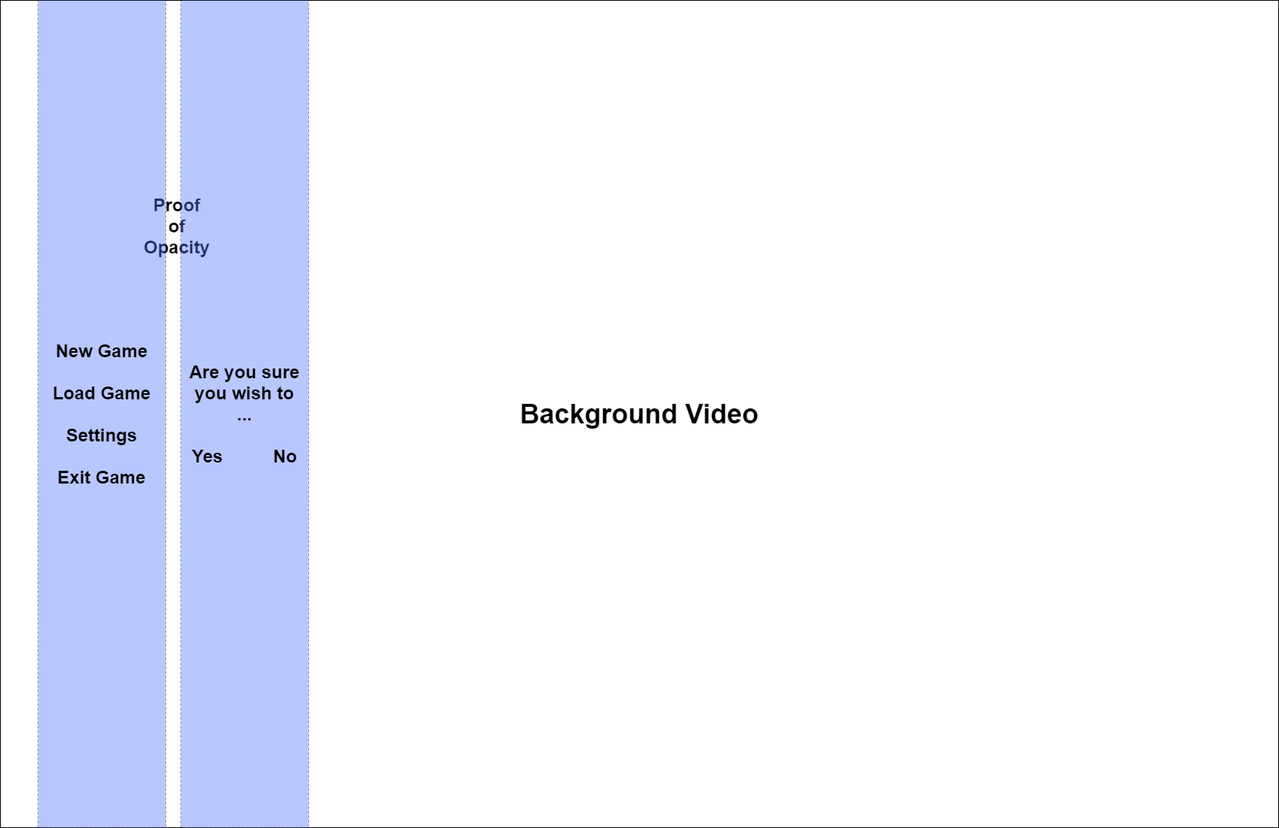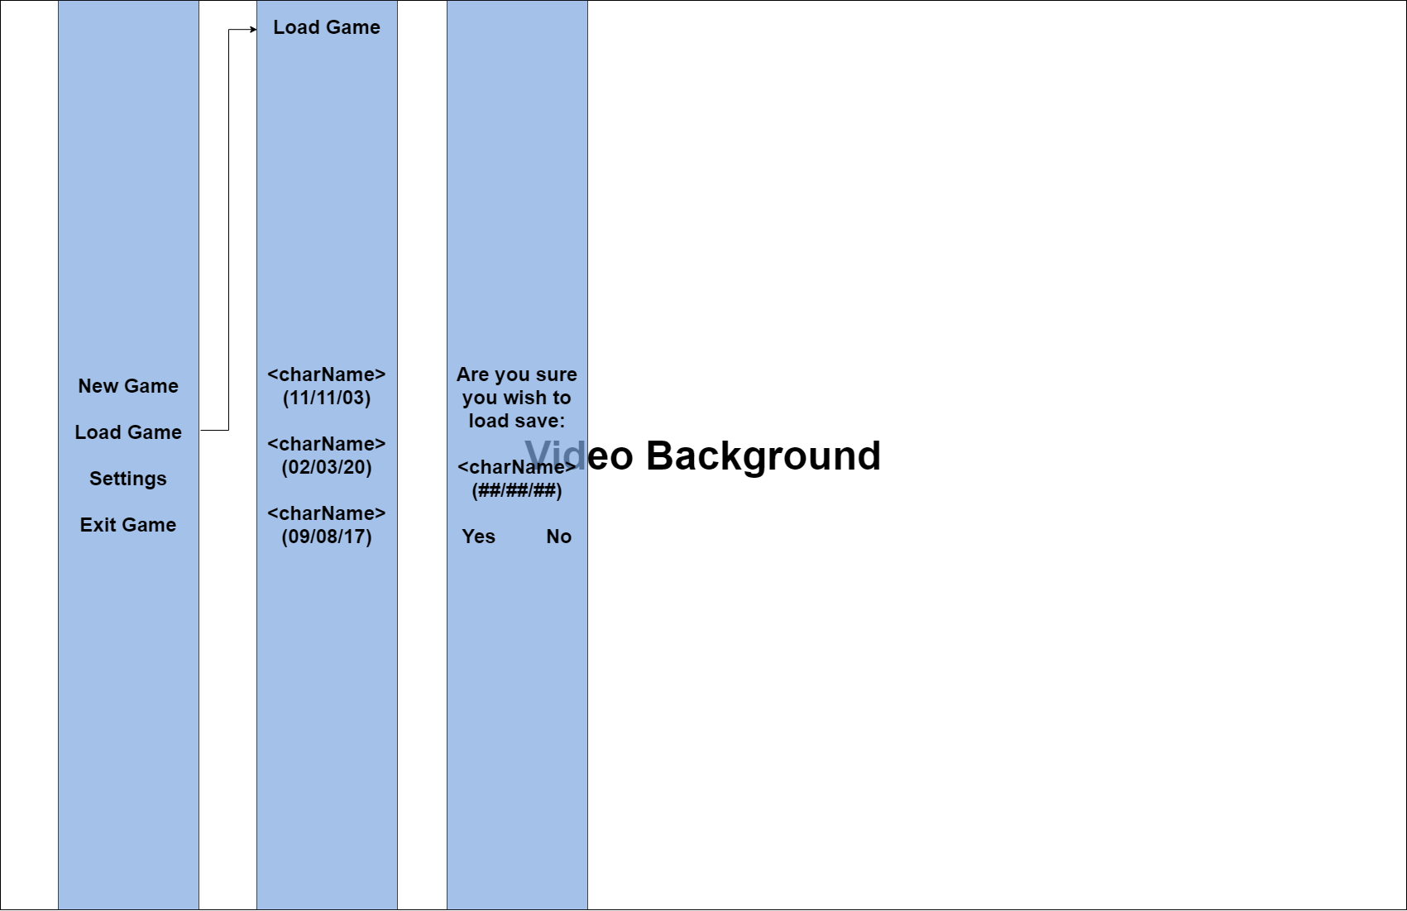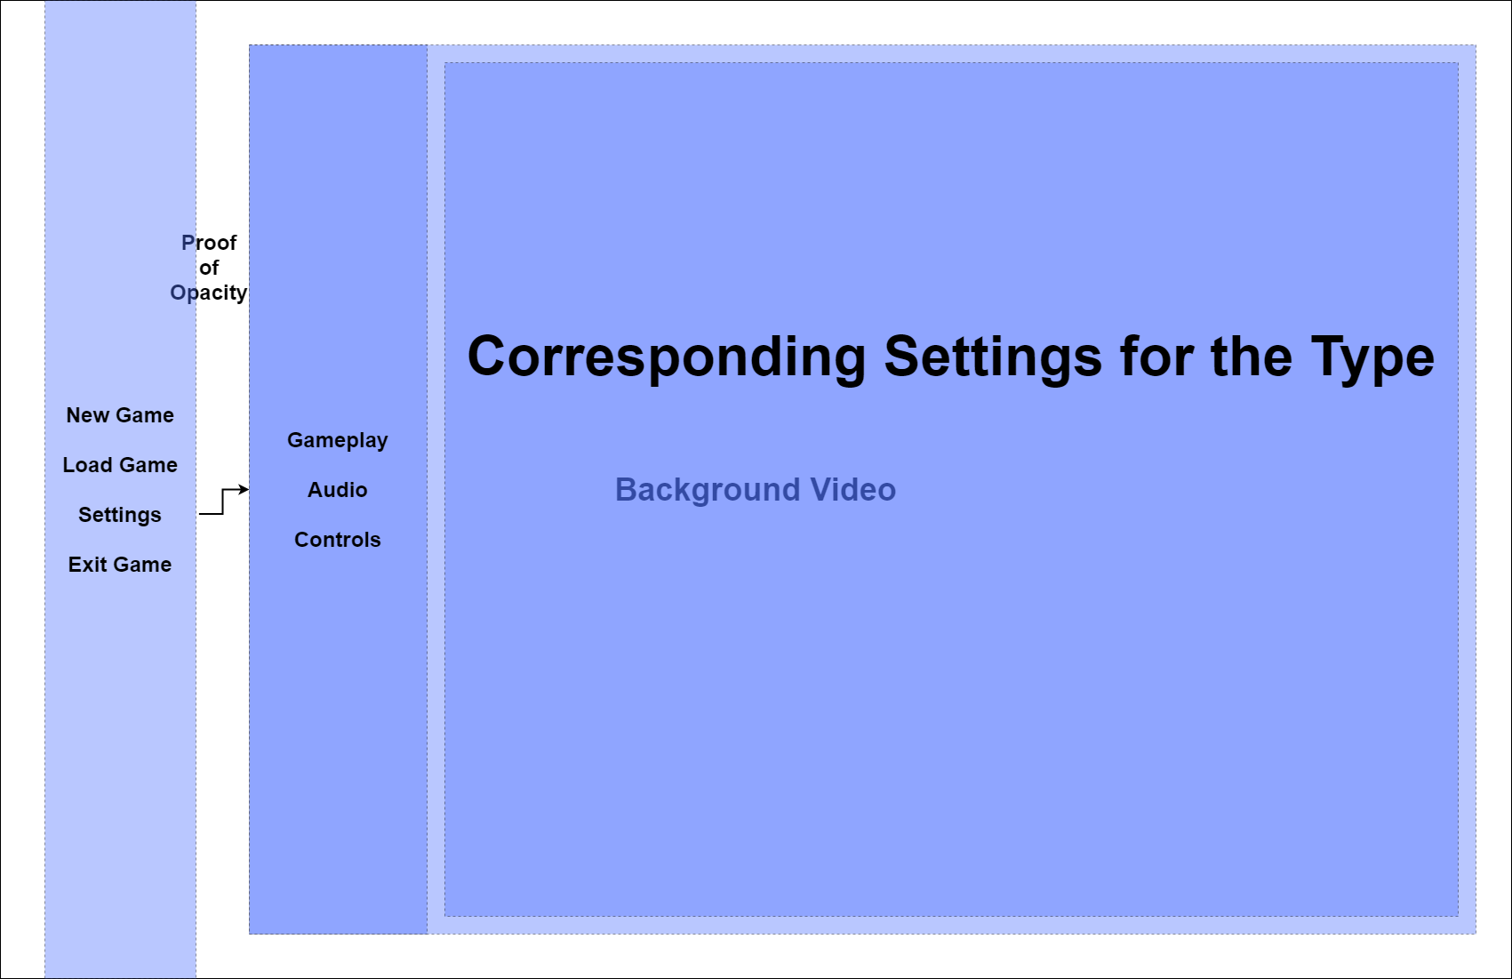

### Explanation of Features

| Feature | Justification / Limitation |
| --- | --- |
| Low-Poly / Origami Graphics | Lowers the impact of the game on the user’s computer and for aesthetics. |
| High-Quality Sounds | Despite the possibility of large file sizes, this may improve how realistic it is, making it more surreal. What would a game be without sound anyway? |
| Physics | To add more in-depth detail to the game, instead of having static models with animations. |
| Character Creation | While it is limited, it is a good way for the player to express their creativity. Maybe contributing to the game? |
| No Multiplayer | No server exists for me to host the game on. |
| Combat | Attacks land when hitboxes of weapons, skills/spells, projectiles collide, combat A.I. gets harder as the player levels up. |
| Statistics | A great way for me or the player to keep track of the player’s attributes that may be affected by enchantments or spells/skills. |
| Debugging | Especially great for anyone testing the game or for myself; helps to generate bug reports using a console. |
| Background | Gives more realism to the game as the day fades into night and night into day using multiple images for the alignment of planets etc. |
| Questing | To ensure some form of progression in the game, and to aid with the combat A.I.’s progression, along with levelled items - depending on area. |
| Bartering | Somewhere for the player to sell their junk, unwanted equipment and rare items; they sell rare items, junk and other items. Items sold vary between merchants but buy all from you. |
| Safe Zones + Guards | To ensure the player doesn’t straight away become a mad  man / woman killing everything on sight, stealing etc. Adds some aspects of justice. |
| Cutscenes | A way of conveying a story to the player such as the main quest line that is important. |
| Tutorial | To help the player understand how to play the game and how everything works instead of throwing them straight into the game. |
| Attributes | Base stats of the player in this game, more useful in the code than it is for the player, unless they wish to strategize and focus on one thing compared to another, such as a tank build or DPS. |
| Crafting, Gathering, Mining, Chopping, Fishing, Upgrading, Star Evolution | Allows the player to grind and overcome difficulty barriers within the game, this may give them a temporary sense of power, that will give them moments to breathe as the game gets progressively more difficult. |
| Secret Stones: Embedding, Extracting, Upgrading, Evolving | Allows the player to enhance their items and allows them to improve them or make higher quality stones, which improve the items more so. This could be pretty useful for the player. |
| Excavation/Archaeology | If the player decides to, they can perform archaeology every so often (in-game time) and they will have chances to get great loot or things to trade for tokens in exchange for things like maps or loot. |

### Software and Hardware Requirements:

#### Hardware:

| Item |  |
| --- | --- |
| Keyboard | To allow the user to move around and interact with the GUI. |
| Mouse | To allow the user to look around, interact with the GUI and surroundings. |
| Audio Output Device | Not necessarily required, but it does improve the quality of the game overall. |
| Monitor | Allows the user to actually see what they are doing and so they can effectively interact with the game. |
| At least 25 GB of available space (contiguously) | Free space for all materials used in the game, any updates and any necessary caching of the different areas, models etc. |
| RAM:  At least 3 GB of RAM | This may not be present in most computers but it is recommended that they have at least 3 GB of RAM in order to continue running the game smoothly. |
| Minimum:  Intel Core i5-3340S @ 2.8 GHz or AMD Phenom II X4 945 @ 3.0 GHz  Recommended:  Intel Core i5-2500K @ 3.3 GHz or AMD Ryzen 5 3600 @ 3.6 GHz or better | While I am unsure about what kind of CPU the user should have, I would recommend these two for the minimum and recommended, it may help if you have less than 3 GB of RAM. |
| Sound Card:  Minimum:  DirectX 9.0c compatible sound card with latest drivers  Recommended:  DirectX 9.0c compatible sound card 5.1 with latest drivers | Required for effective processing of sound along with HRTF sound, so the user can tell where the sound is coming from etc. |
| GPU:  Minimum:  NVIDIA GeForce GTX 460 or AMD Radeon HD 5870 (DirectX-11 compliant with 1GB of VRAM)  Recommended:  NVIDIA GeForce GTX 670 or AMD Radeon HD 7970 or better | In order to effectively process and display the graphics of the game, that may use shaders, lots of polys etc. |

#### Software:

| Item |  |
| --- | --- |
| DirectX 9.0c or better with the latest version, must be compatible with the sound card. | Required for handling tasks related to the multimedia within the game and different scenes. |
| Draconia Run-Time Library (should come with the game) | Required for any additional handling to do with the game. |
| SQLite Library | Required for handling databases with logins etc. |
| Any desktop platform:  Windows   * OpenGL API for Graphics w/ OpenAL API for Audio * Microsoft Visual C#/C++ Express 2010 (MSVC) * OpenAL Windows Drivers   Linux  macOS (OS X) | Required for the game to effectively run and so the user can use their hardware. |

### Requirement Specification:

| Requirement | Justification | Reference |
| --- | --- | --- |
| Game has a fixed 3rd person view, the player is unable to enter first person. The player can view the character from all, if not most, angles. | This is more for programming simplicity, not to mention it gives the player the ability to look around at 360 degrees around a point on any axis. The player will only see everything with a perspective of 70 degrees however, since this removes the stretching of models that are further away from the centre of the camera. | *Proposed Solution* |
| This game uses multiple 3D models and meshes to create the landscape and general environment, including the player and enemy. | I have to create character models using design concepts then translate them into blender and generate a model in 3D space, which I can then texture and extract its atlas.  For now I’ll probably just use a single model for the character and one for an NPC. As this is just a pre-beta version. | *I require Blender, version 2.9.0 or higher, and the C.A.T.S plugin.* |
| This game has animations and dialogue for any non-player characters as well as animations for any players actions, i.e. searching/gathering or attacking. | This makes the game more surreal, and helps keep the player immersed as it isn’t just a standard model in an A-pose or T-pose sliding around doing things - although that’d be pretty funny. | *I require Unity Hub and Unity of 2019f or higher.* |
| This game contains somewhat complex controls as well as most of the basic controls you’d expect from an RPG. | This game can require some strategy for bosses etc., such as using the right combo of skills - there is no combo, just sometimes it’s more favourable to use one skill over another based on the enemies weaknesses.Aside from this, it also includes moving and dodging. | *The ability to code scripts that will execute a command based on user keypress.* |

### Systems Diagram:

### Proposed Screen Design and Usability Features:

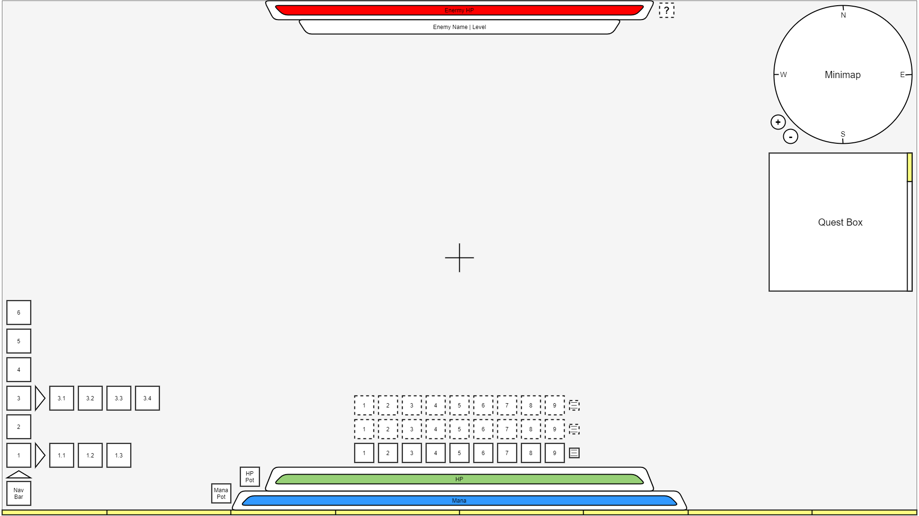

### Overview of Scripts:

In my program I will use basic scripts and slowly make them more complex (identified by italics, notes on this script as a whole may be included) as my depth of knowledge grows; these scripts will be:

#### Basic Combat A.I. / ***Advanced Combat A.I.****:*

This will be implemented at some point in the future as I doubt I have the patience to create an A.I. that learns how to beat the player, being capped at a difficulty, so you can still beat it.  
  
In the meantime I will settle for creating a simple detection system, such as:  
  
I see/hear the enemy! → I (locate then) attack the enemy! → I will occasionally try to defend myself!  
  
When the NPC engaged in combat is low on health, or an ability has been cast on it, that inflicts fear into them (depending if they are resistant or not), they will flee a distance from the player, before stopping to attempt at healing itself, or until the effect wears off. In low difficulties it will go to a point at least 5 metres from the player, in any direction it chooses is the wisest, for A.I. on the lowest difficulty, this will make combat very anticlimactic, a bit like child’s play. As the difficulty increases, the minimum distance increases by 3 metres. If the player pushes the NPC within the range of this, it will try to run away some more, but if it is healing itself, it will stay put, making itself quite vulnerable to the player. Making it more advantageous to follow NPCs with low health when in combat with them, rather than chasing feared ones that will constantly run away when you get too close. If the NPC in question cannot heal itself, whether that be via potions or an ability, they will act as if feared, although they will surrender once they’ve reached the minimum distance from the player, making them just as vulnerable as before. If the player hits the NPC at all during this time, it will reset this and it will continue to run away and stop and so on and so forth. When the player hits an NPC that is healing, it’s action is cancelled, causing it to either repeat the action or flee further away.

*For the advanced A.I., I will have all NPCs that can be provoked by the player to use a single mechanism that builds upon itself slowly after each confrontation with the player. This means that the more times a player farms a location of enemies for related loot or defends themselves from nearby events such as an ambush by bandits, the A.I. gets smarter and predicts the moves and steps the player will take to defeat them. This will be capped at some stage, where the A.I. don’t have complete control over the player, but make it a challenge for players to deal with the enemies, as they will try anything against the player, finding weaknesses and combos that are effective against the player. The amount that the A.I. will learn per battle also depends on the difficulty, which was set by the player; if the player changes it mid-way through a game, the A.I. is only affected starting next combat, it will never retrace its steps and attempt to learn more that it already has. A.I. will also learn to search for cover when necessary, as to avoid any arrows that may come their way. And if they are constantly being interrupted when healing, they may try to flee further than before, so instead of 5 metres away they flee 10 metres away, and behind cover or somewhere safe, if the player doesn’t attack the NPC for another minute, combat is automatically ended. That is unless it is in a boss room in a dungeon.*

***For information on how the level of the enemy affects the difficulty see*** ***Linear Progression******.***

#### Basic Pathing ***/ Advanced Pathing:***

Find the shortest distance between two points, given coordinates of the destination and current location of the player/NPC. No glitching through walls, do not avoid enemies, and factor in obstacles; finding the shortest distance to cover in the shortest time and/or that consumes the least stamina; has the ability to trace up climbable surfaces if it cuts time.  
  
*Depending on the difficulty, the pathing follows a strict guideline of what to do and what not to do. It will still do its job as stated above, however, if the player is playing on the easiest difficulty, there will be a margin of error to the pathing, where it will never be the shortest possible route. But it will still try to get a path to the destination as the shortest route based on new parameters. Such as, on the easiest difficulty, the player will avoid all hostiles within 15 metres. As the difficulty increases, 3m will be shaved off this value until it is 0 metres; in which the pathing will be the shortest route and will not avoid hostiles at all. This means that if the path crosses that of a hostile, both the player and NPC will collide, and start combat assuming it hasn’t started already by the hostile’s detection system.*  
  
Rules:

* If the player is within 12.5 metres of any hostile creatures, that creature will path to the player and engage in combat.
* When a player is engaged in combat, disable auto-move, and pause pathing, but as soon as combat is over, resume pathing and prompt the user if they wish to continue auto-moving.

Simple Detection / ***Advanced Detection***:  
Simplest is to find whether or not the player is within a set FOV, where a series of lasers are fired from the origin point of the FOV and will decrease in strength proportionally to the distance from the origin point. *When it comes to blind spots these will start at ¾ of the original strength, which will only occur within the lateral radius of these, being 2 ¾ degrees; the closer to the centre of these blind spots, the smaller the starting factor - therefore at centre they will start at ½.* Also it can be said that beyond the dashed lines (last 10 to 8 degrees of the temporal crescent), the starting strength factor is at ½ . For the fixation points, these will start at 1¼ of the original strength at the centre and the further from the center the closer the strength gets to the original strength; fixation points are 3 degrees in radius. These effects come into effect when the player enters the area specified, which goes up and down by 3 metres. Area cuts off at around 12 to 15 metres from the point of origin/eyes. This model does not involve sound detection, so this script is extremely limited and may be game breaking. The following is the radius/FOV of the NPC in 2D aerial view.  
 *Using the same rules as above, include the vertical spectrum and apply similar effects; within the binocular and central vision cones, apply a starting strength factor of 1 ⅙. Between the last 7 ½ to 6 ⅔ degrees of the lower peripheral vision. Below is a 2D-side view of the visual detection system representing the height.*  
  
When it comes to finding the exact point of fixation, draw straight lines from the centre of the pupil of the eyes outwards, these two lines can intersect at any point on a surface, the closest surface being 2.5cm from the eyes, else the NPC may have temporarily impaired vision until the eyes are focused on something further away. This effect will be similar for players too, if they get too close to a surface, their vision will go blurry, to make it more realistic  
  
*Create a 3D sphere at the origin of the sound, strength determines the size of the radius of the sphere, any walls or objects in the way, truncates the portion of the sphere that comes into contact with it, where the chance of hearing the sound is the chance at contact minus the thickness of the object, in metres, over the strength of the sound (radius), in metres, multiplied by 100. If the NPC’s ears are within the sphere’s radius, 1 minus the distance from the hitboxes of the ears to the point of origin divided by the strength multiplied by 100, defines the chance the NPC has of hearing the sound. Soon I will implement densities and the wavelength/frequency of the sound.  
  
  
  
  
  
  
  
  
  
  
  
  
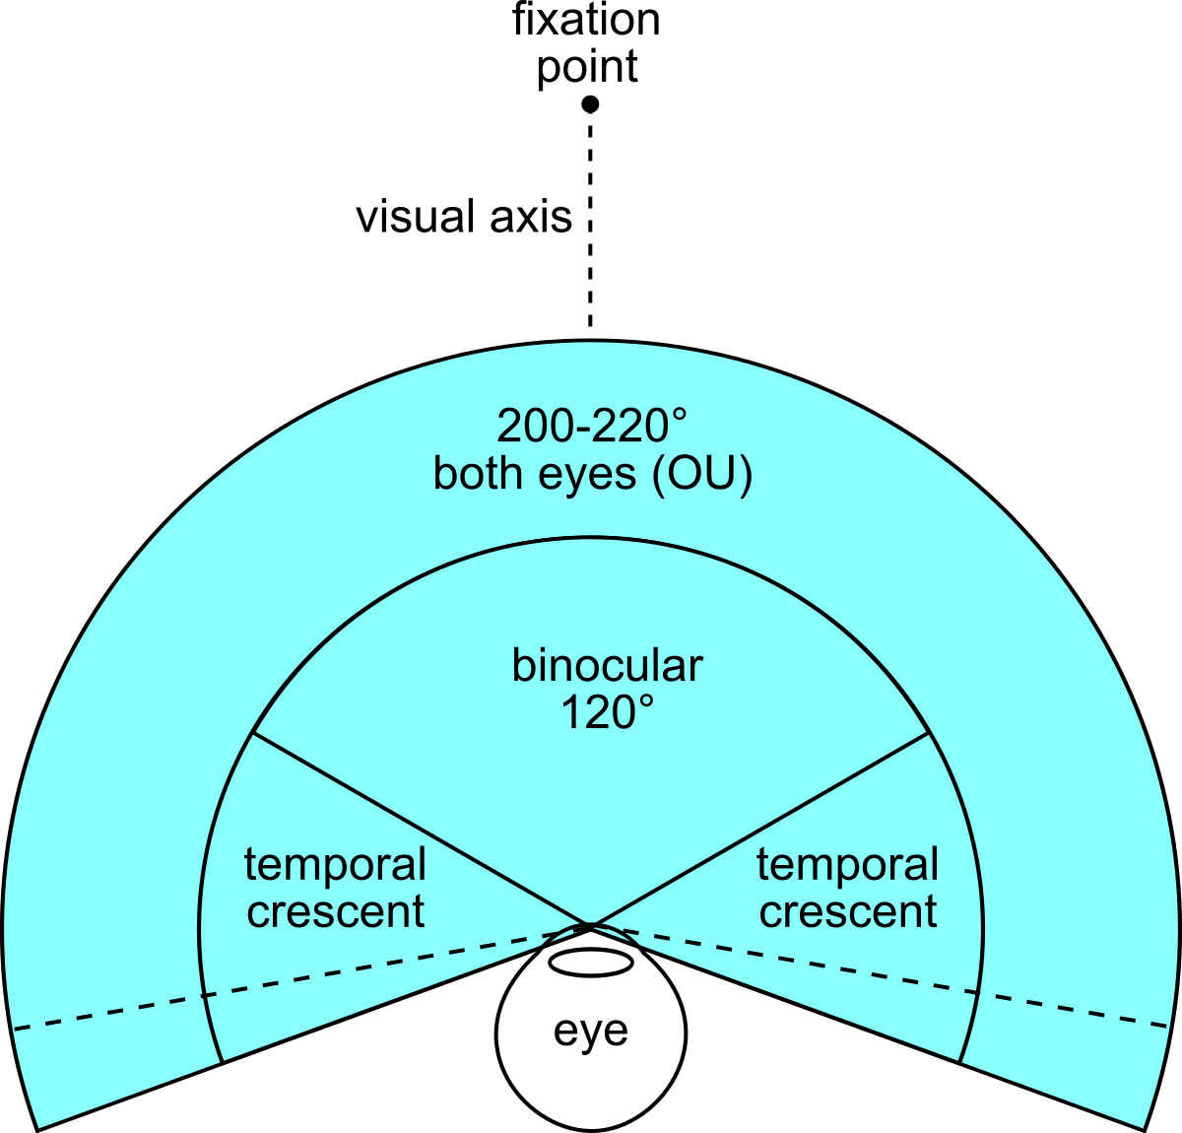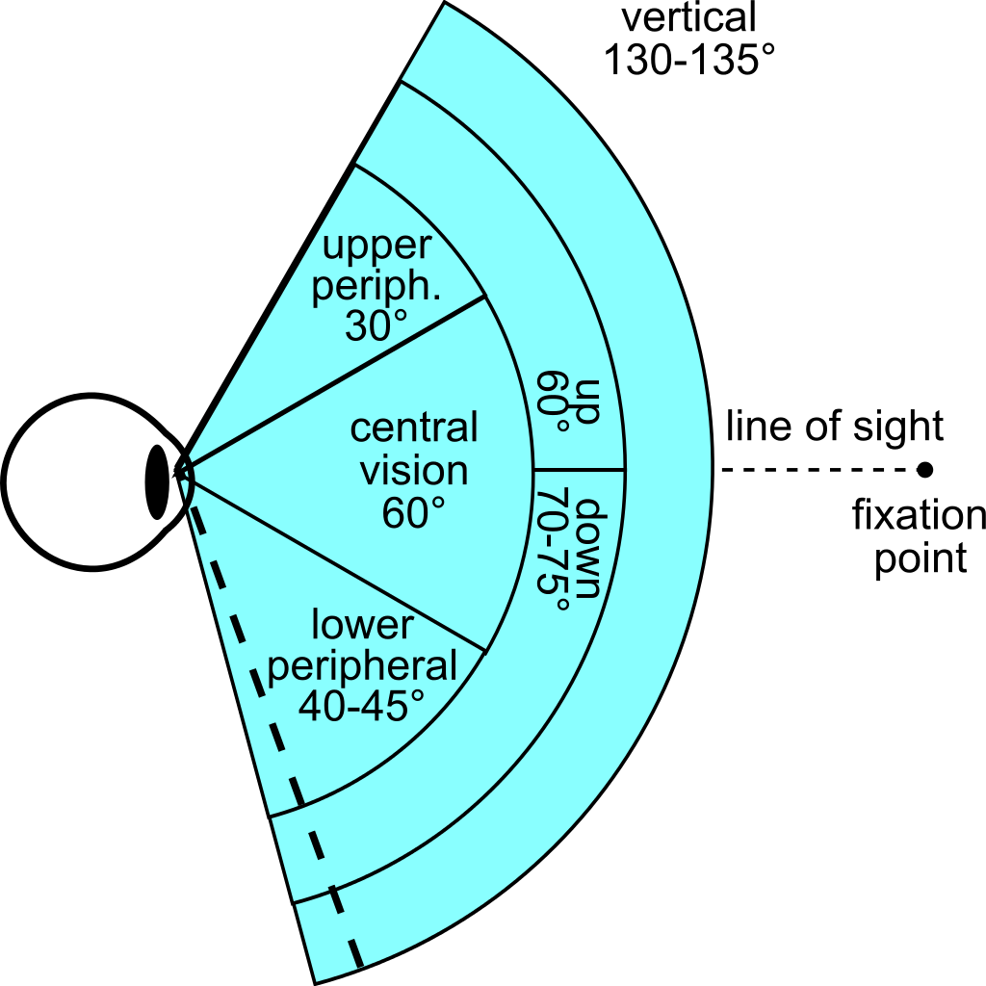*

#### Information Collection (**ALL EFFECTS STACK**):

When a player first encounters a monster or NPC which the player can engage in combat with, the health and level will be unknown until the first knowledge level is met.  
  
  
   
  
*Basic* (1) - When the enemy is first encountered, the player gets a 5% XP Bonus for all the times the player has killed this specific enemy from this point forward, this effect lasts after the first kill for 10 minutes, if combat is in progress with an enemy that is affected by this bonus, the bonus applies for another 10 seconds as grace period.  
*Location* (2) - When the enemy has been killed a set number of times, the player gets a 15% XP Bonus and a 5% Loot Bonus, using similar rules above, lasting 15 minutes, with a 10 second grace period.  
*Item* (3) - When the enemy has been killed a set number of times, the player gets a 25% XP Bonus, 15% Item Bonus and a 5% Info Bonus - Each time they kill a monster, it counts as 1.05 times the normal; this is applied for 15 minutes, grace period of 10 seconds.  
*Origin* (4) - When the enemy has been killed a set number of times, the player gets a 30% XP Bonus, 25% Item Bonus and 10% Damage Bonus. No more info can be gained after this and this buff is permanent against this enemy.

#### Simple Targeting (Basic Combat A.I.) / ***Advanced Targeting***:

Target will always be directly behind the player on a surface where the projectile arc coincides with the player’s body’s hitbox; this helps to keep things in a 2D form, where it can be scaled appropriately for 3D. The intended target directly behind the player will determine the coordinates of where two lines intersect; the NPC should only fire when the projectile arc collides with any area within the player's hitbox.

#### **Acceleration & Deceleration - Movement**

When the player hits one of the direction keys, apply a vector then an appropriate acceleration to that, where the acceleration should be the same in every direction and the velocity gained is capped at around 5 m/s normally, this maximum will increase based on certain factors or decrease depending on others, for example, they could have a movement speed boost, this will subsequently increase the max speed by the same amount; another example is they could be over-encumbered, which means they’d be slower. When the player stops holding down the movement key, a constant deceleration should be applied to mimic the player’s character realistically coming to a stop. Acceleration vectors and deceleration vectors should also depend on the type of surface, like ice - this could mean the deceleration takes longer, and acceleration could take a little longer to gather the maximum acceleration. The acceleration of anyone moving should have the following equations, where the acceleration is found by finding the y-coordinate of any point on the curve in respect to the current velocity (x-coordinate).

Curve changes with the movement speed bonus, and the maximum velocity achieved. The value will be the current velocity and the value will be the current acceleration, whenever a direction is held, and while the value of velocity is not 0 and no movement keys are pressed until speed reaches 0, it will always take the same amount of time to decelerate no matter your velocity, the constant deceleration equation is: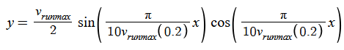

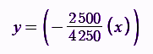

If the player decides to assist in deceleration the same acceleration equations are used, but are negative instead. It completely negates the constant deceleration equation and only applies the negative of the acceleration curves taking into account the deceleration constant, making it more efficient than just simply stopping. These equations would look like:

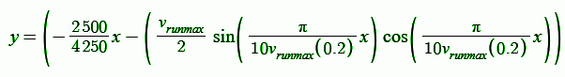

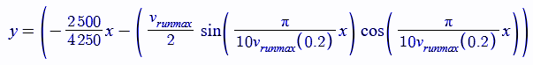

Graphical versions are shown below, colour on graph matches the equations above.

Axis are acceleration(+)/deceleration(-) (y-axis) and velocity (x-axis). Changes will be made.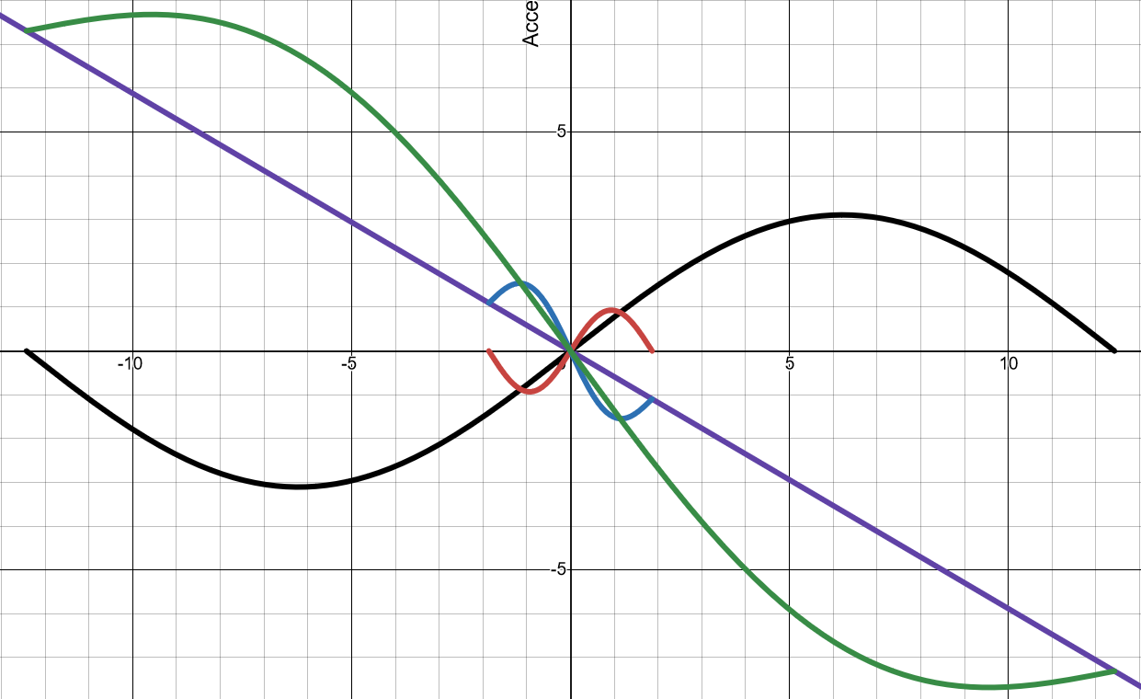

**Changes were made:**

* n is used in the formula for v; this has been changed from *0 to 0.242771*, to **0 to 1**.
* Formulae for v have been adjusted accordingly.
* Walkmax for v has been increased from *1.8641565* m/s max to **2.228313** m/s.

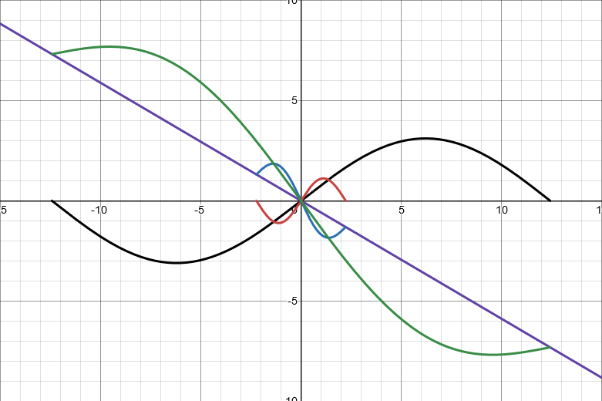

#### **Ground & Model Collisions - Physics**

Create collision meshes on each model, or take points below the character using a plane and make sure any point on the surface of the ground has the same vertical value as the plane below the character or the collision meshes coincide with one another. As for walls, a similar effect will be used but instead of a plane, a cuboid will be used, where it detects the centre position of the player’s model and the point on the ground it is; for walls it will apply the same effect but vertically, and if more than 40% of the player’s hitbox, the player cannot move up that wall via walking and will have to climb. When 100% of the player’s hitbox coincides with a wall, they will be prompted with the option to climb, until 80% of the player’s hitbox coincides with the wall, once it passes this threshold they can lift themselves up onto the ledge. When a player’s hitbox collides with another hitbox that can move or isn’t seen as a part of the surface or you cannot pass through it, the players speed will be reduced to near zero, until the player’s outer model coincides with the model it is colliding with, in which it stops the player completely.

#### **Model to Model Collisions - Physics**

Damage, etc.

* Take into account densities and hardness of all objects and walls, how much sound energy is released from a sound (strength), how much force is used against the object, use Rockwell/Vickers hardness test.
* **Climbing should be a timing game; where depending on the bearing from the point the player is holding and the point the player wants to reach, where distance increases the difficulty lowering the threshold, and as the threshold nears impossible near to 2.5% of the full arc they will be unable to make the jump/climb in that direction. If the player fails to meet the threshold by a small amount, up to 10% either side of the threshold the player will need to perform an action to save themselves or fall down to the beginning or whatever lays below them. The player can select jumps within a set area using the left or right arrow keys, where the nearest jump is targeted first; this is where the nearest takes index 0 in a list where each point’s index is determined by its displacement from the player. Use:** [**https://www.desmos.com/calculator/gha45lg0s6**](https://www.desmos.com/calculator/gha45lg0s6)

#### **Camera Lock-on and Point Rotation:**

Using the GetAxis function I can determine the magnitude of the pointer on the screen, for example it could be at (-0.783…, 0.971…) where the function finds the position of the pointer in steps of 0.05f between values of -1 and 1 on both the x and y axis.  
The Y-axis will translate into the X-axis and the X-axis will translate into the Y-axis in game; I am unsure as to why this is, but this works and I’ll have to just work with it.

**Cosine, and Sine will be used to determine the vector distance between 2 points, where we know an angle and the fixed distance the camera will be from the player. In the first quadrant, for the first 45 degrees, cosine will be used, then for the next 45, sine, and the next 45 after that -ve sine, and the next 135 degrees after that cosine, followed by sine for the last 90 degrees. We can then use sine for the vertical angles, and find the corresponding z-axis value.**

### Gamestates - Evidence of Coding

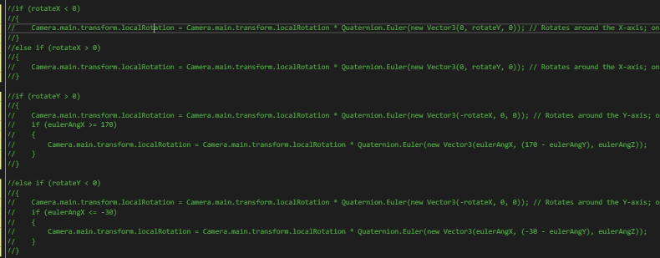  
Code above was designed to counteract any changes in the camera’s rotation, sadly this does not work and I have to find a work around for this; it does not work as the camera would freak out at the slightest movement of the mouse and the boundaries set would cause it to derail even further.